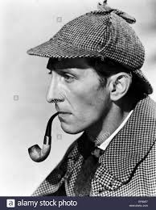**FAMOUS DETECTIVES**

**Sherlock Holmes** : He was an **infamous gentleman detective** created by **Sir Author Conan Doyle.**  Detective Holmes has been the inspiration for many, many investigative characters since his birth in the late 1800s. As a detective, he is known for his **logical reasoning**, early use of **forensic science**, and **penchant for costume**.  *Quote:* “Elementary, my dear Watson ». This quote is representative of the character and his attitude.

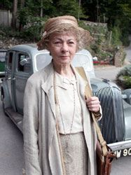**Miss Marple** : She was created by **Agatha Christie**. Jane Marple appeared in 12 novels and 20 short stories as an **elderly spinster** who fills up her free time **resolving the mysteries** in her home of St. Mary Mead. She is the **counterpart to the gentlemen detective genre**, a **well-bred, well-educated older woman** applying her keen **wit, experience, and knowledge** to the challenges of solving crime. Quote : « It’s what’s in *yourself* that makes you happy or unhappy.”

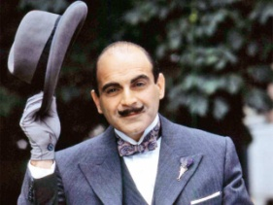**Hercule Poirot** : Mr. Poirot was created by **Agatha Christie** alongside Miss Marple, this **dignified** **Belgian detective** solves crimes with the use of **logical reasoning**, or as he puts it ‘**order and method’**. Mr. Poirot also appeared on stage, in a number of film adaptations, several television shows, an animated series . *Quote:* “Chief Inspector, you have been thinking again. I have warned you of this before.”

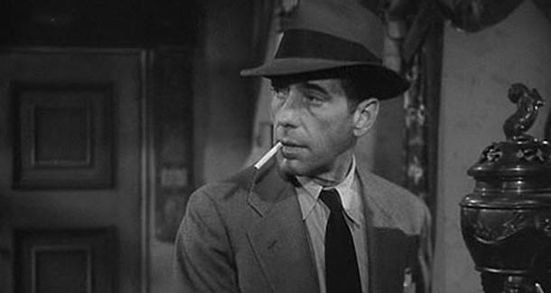

**Philip Marlowe** : One of the most significant figures in the ‘**hardboiled crime** **fiction’ genre**, Marlowe was first created by **Raymond Chandler** in 1939 for « **The Big Sleep** ». Philip is the **hard drinking, gruff yet oddly charming PI**. His **rough** personality is rounded out with a **thoughtful mind** well versed in **poetry, philosophy**. He drinks **whiskey and loves his coffee**. *Quote:* “ I don’t mind if you don’t like my manners. They’re pretty bad. »

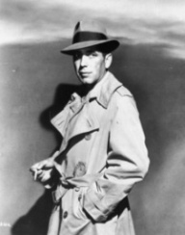

**Sam Spade** : Famously portrayed by **Humphrey Bogart** in one of the movie adaptations of his book, **The Maltese Falcon**, Sam Spade is **not at all a gentlemen detective**. He’s a **shifty character** capable of getting himself in and out of fixes **with equal skill**. Despite disliking his partner, he goes all out when the man is murdered to bring his killers to justice.

**Columbo** : A **homicide detective for the LAPD**, Peter Falk is a **gregarious, slightly rumpled** detective. He tends to **talk too much** and often seems to be a bit of an **airhead**, though in reality he has a keen **attention to detail** and a **quick wit** that helps him piece together the events of the crimes he investigates. *Quote:* “Perfect murder, sir? Oh, I’m sorry. There is no such thing as a perfect murder. That’s just an illusion.”

**The Scoobydoo gang** : The gang of **teenaged friends** and one **oversized dog** solve mysteries. These friends include : the couple Daphne and Fred, the intelligent and shy Velma, the fumbling and perpetually starving Shaggy and his trusted and trouble-maker Scooby. These teens have a **knack for using fear** **of the supernatural** to conceal criminal activity. *Quote:* “Velma, here’s the only thing you ever need to know about boys. They are stupid. If you give a boy two choices, a smart one and a stupid one, he will always make the stupid one every time »

**FAMOUS DETECTIVES**

**Sherlock Holmes** : He was an **infamous gentleman detective** created by **Sir Author Conan Doyle.**  Detective Holmes has been the inspiration for many, many investigative characters since his birth in the late 1800s. As a detective, he is known for his **logical reasoning**, early use of **forensic science**, and **penchant for costume**.  *Quote:* “Elementary, my dear Watson ». This quote is representative of the character and his attitude.

**Miss Marple** : She was created by **Agatha Christie**. Jane Marple appeared in 12 novels and 20 short stories as an **elderly spinster** who fills up her free time **resolving the mysteries** in her home of St. Mary Mead. She is the **counterpart to the gentlemen detective genre**, a **well-bred, well-educated older woman** applying her keen **wit, experience, and knowledge** to the challenges of solving crime. Quote : « It’s what’s in *yourself* that makes you happy or unhappy.”

**Hercule Poirot** : Mr. Poirot was created by **Agatha Christie** alongside Miss Marple, this **dignified** **Belgian detective** solves crimes with the use of **logical reasoning**, or as he puts it ‘**order and method’**. Mr. Poirot also appeared on stage, in a number of film adaptations, several television shows, an animated series . *Quote:* “Chief Inspector, you have been thinking again. I have warned you of this before.”



**Philip Marlowe** : One of the most significant figures in the ‘**hardboiled crime** **fiction’ genre**, Marlowe was first created by **Raymond Chandler** in 1939 for « **The Big Sleep** ». Philip is the **hard drinking, gruff yet oddly charming PI**. His **rough** personality is rounded out with a **thoughtful mind** well versed in **poetry, philosophy**. He drinks **whiskey and loves his coffee**. *Quote:* “ I don’t mind if you don’t like my manners. They’re pretty bad. »



**Sam Spade** : Famously portrayed by **Humphrey Bogart** in one of the movie adaptations of his book, **The Maltese Falcon**, Sam Spade is **not at all a gentlemen detective**. He’s a **shifty character** capable of getting himself in and out of fixes **with equal skill**. Despite disliking his partner, he goes all out when the man is murdered to bring his killers to justice.

**Columbo** : A **homicide detective for the LAPD**, Peter Falk is a **gregarious, slightly rumpled** detective. He tends to **talk too much** and often seems to be a bit of an **airhead**, though in reality he has a keen **attention to detail** and a **quick wit** that helps him piece together the events of the crimes he investigates. *Quote:* “Perfect murder, sir? Oh, I’m sorry. There is no such thing as a perfect murder. That’s just an illusion.”

**The Scoobydoo gang** : The gang of **teenaged friends** and one **oversized dog** solve mysteries. These friends include : the couple Daphne and Fred, the intelligent and shy Velma, the fumbling and perpetually starving Shaggy and his trusted and trouble-maker Scooby. These teens have a **knack for using fear** **of the supernatural** to conceal criminal activity. *Quote:* “Velma, here’s the only thing you ever need to know about boys. They are stupid. If you give a boy two choices, a smart one and a stupid one, he will always make the stupid one every time »