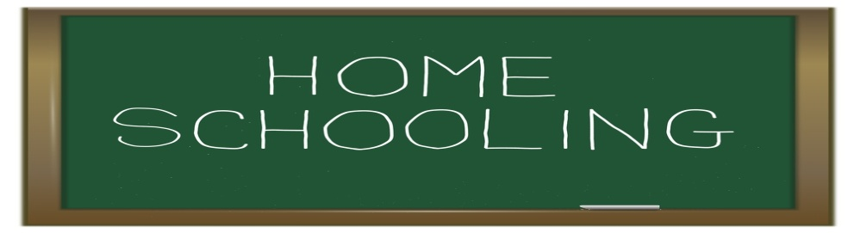
A new school year has begun in America. But some children do not go to school. Instead, they learn at home, usually with their parents as teachers. Educational companies, libraries, school systems and the Internet provide families with teaching material.
Homeschooling is increasingly popular. Homeschooling groups estimate that two million children (around two percent), learn at home. The last government estimate was 850,000 in 1999. Current numbers are not expected until next year.
Some parents choose homeschooling because of their religious beliefs. Others say it provides more time for the family to be together. Many parents also believe homeschooling avoids problems of a lot of traditional schools. One problem is classes with too many students.

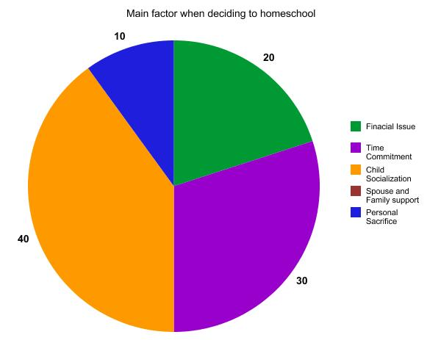
Critics, though, say children need to attend school with other children to help them learn things like social skills. They also say that some homeschooled children do not get a very good education.
All fifty states and the District of Columbia permit homeschooling. Some, however, require more preparation by parents or testing of children than others do.
Homeschooling is as old as the country. In farm areas, people often lived far from a school. Then, in 1852, the state of Massachusetts passed the first law to require children to attend school. The public education system grew. By the nineteen sixties and seventies, however, some Americans believed that traditional education was not helping their children. So a number of parents began homeschooling.
Homeschool expert Linda Dobson says some parents began to teach their children at home when some religious schools closed. This happened after changes in tax laws in the nineteen eighties. Since then, she says, more people have joined the movement -rich and poor, and people from many races, religions and political beliefs.
There is even a "National Home School Honor Society". Membership is based in part on the same tests that students take in school.

Homeschooled children go to college and have also won top competitions. These include this year's National Geographic Bee. Fourteen-year-old James Williams knew that the Indian state of Goa is a former colony of Portugal.

Match the word with its meaning

- popular ______ the feeling of being certain that something exists or is true
- belief ______ containing too many people or things
- overcrowding ______ to make something possible or easier
- permit ______ the state of belonging to an organization
- membership ______ liked, enjoyed, or supported by many people
- to facilitate ______ to allow something

Answer the questions

1. The term "homeschooling" refers to ...
- an educational program accessible on the Internet.
- an education system where teachers go to families to do class.
- a system that allows families to teach their own children themselves.
- an education system set up for religious reasons.

2. "Homeschooling" ...
- is a system as old as the United States itself.
- is a new phenomenon in the USA.
- is a tradition within religious families.
- was put in place and developed by the previous government.

3 "Homeschooloing" concerns today ...
- the majority of children of school age.
- about half of school-age children.
- a tiny minority of children of school age.
- only children with an Internet connection at home.

4. Today, "homeschooling" ...
- is only allowed in some states.
- is authorized in all states except "District of Columbia".
- is only allowed in the state of Massachusetts.
- is authorized in all states.

5. The United States consists of ...
- 48 states.
- 49 states.
- 50 states.
- 51 states.

6. According to some, all children should attend a traditional school ...
- for religious reasons.
- to facilitate the socialization of children.
- to promote equal opportunities for children.
- because only the traditional school is able to teach children that GOA is a former Portuguese colony.

7. "Homeschooling" and legislation.
- In most states, local authorities have little control over the homeschooling system.
- In all states, local authorities exercise very strict control over the system.
- Controls and requirements vary from state to state.
- There is no control over the system.

8. Today, "homeschooling" ..
- concerns only well-off social categories.
- is a system that is practiced only in remote rural areas.
- concerns all social categories.
- mainly concerns children who are too weak to follow traditional education.

9. Among the reasons for some parents to educate their children at home is ..
- the disappearance of the public school in the United States.
- the loss of confidence in the traditional school.
- the pleasure of breaking the law.
- overcrowding in the classes.

10. James Williams is ...
- the head of the National Home School Society.
- a young Indian from the state of Goa.
- a young boy, out of school, who has distinguished himself in a national competition.
- The name given to the 14th National Geographic Bee in honor of a former Portuguese colony.

Using the words below, write a short paragraph on home schooling.
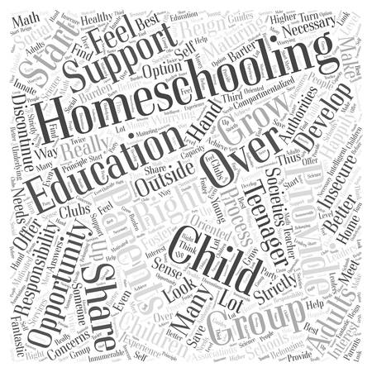
________________________________________________________________________
________________________________________________________________________
________________________________________________________________________
________________________________________________________________________
________________________________________________________________________
________________________________________________________________________
________________________________________________________________________
________________________________________________________________________

Do you think homeschooling is a good idea? What do you think are the advantages and disadvantages of homeschooling? Fill in the table below.
Advantages | Disadvantages

