COMPUTERS AND THE INTERNET
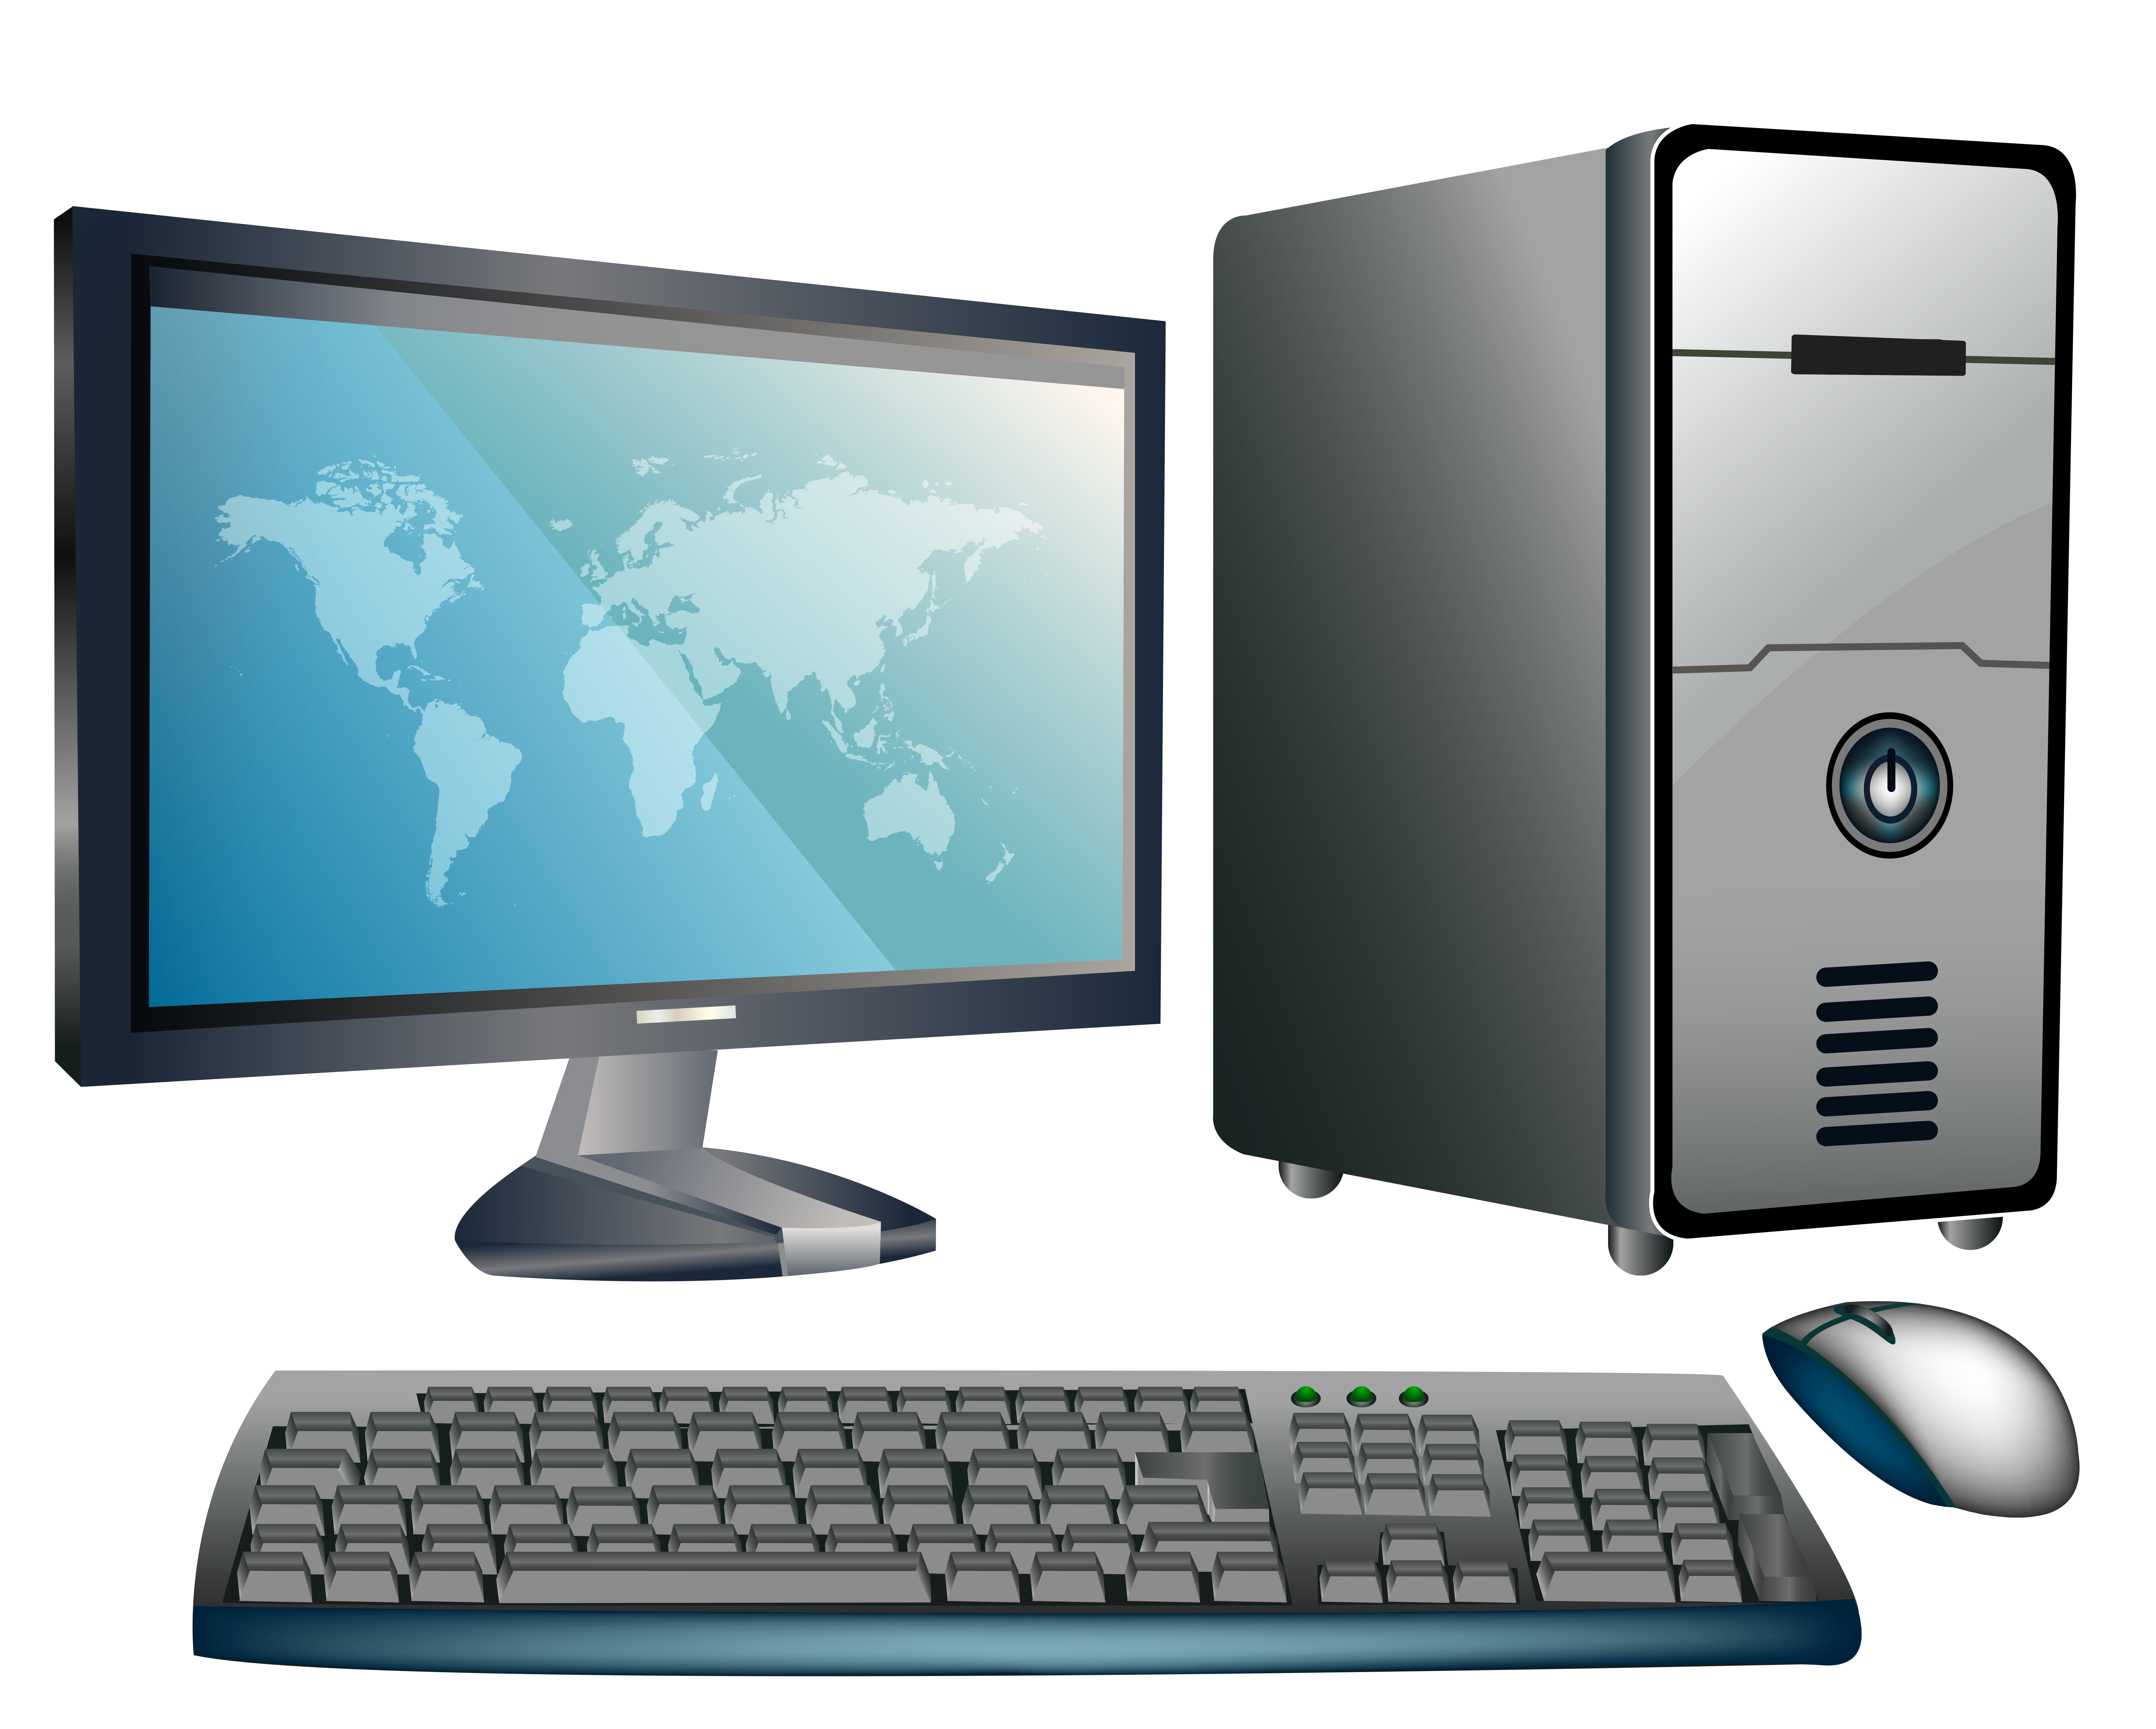
Complete with correct words.
1. an Internet letter (an e-____________l)
2. an Internet diary (a b____________g)
3. a machine which prints your documents (a p____________r)
4. it helps you find information on the Internet (a s____________h e____________e)
5. if you click on it, it takes you to the other website where you can find further information about something (a l____________k)
6. a little arrow on the screen (a c____________r)
7. a document on your computer (a f____________e)
8. a symbol of a program (an i____________n)
9. a traditional type of computer which you do not normally move, you keep it on your desk
(a d____________p c____________r)
10. a board with buttons which you use if you want to write something
(a k____________d)
11. a small thing connected to a computer, you use it if you want to click on something
(a m____________e)
12. one button on a keyboard (a k____________y)
13. a part of a computer where texts or pictures appear (a s____________n)
14. secret letters or/and numbers which only you know and use to log on (a p____________d)
15. a piece of computer equipment that allows pictures or texts to be taken onto a computer (a s____________r)
16. a set of instructions which can destroy information on your computer (a v____________s)
17. a system of connecting computers to the Internet at a very high speed (b____________d)
18. an Internet page (a w____________e)
19. the name of a person who uses a website or a service (a u___________e)
20. a program that allows you to look at websites, e.g. Mozilla,
Internet Explorer (a b____________r)

