New ways of communication
Sir: Today we speak faster then the light speed. Communication and information travel faster than anything we have seen before and the world seems to get smaller and smaller. As a result, this changes the way of communication in the whole world, especially with today’s obsession with social media networks.
Before social media, we were extremely limited in our ways of interaction with others and we were also limited largely to the people that we knew in-person. The Internet and social media have drastically changed the way people all over the world interact and communicate. Now people share their deepest secrets on social media.
We are all getting comfortable handling much more information about each other than we have ever before. We all have more information than we can comprehend. Social networks are becoming one of the dominant ways we communicate. People are more obsessed with checking their smartphone every two minutes than engaging in meaningful conversation with their child or spouse.
The extent to which children and Young people have ability of good social skills can influence their academic implementation, behaviour, social and family relationships, and connection in extracurricular natural action. Social media and technology are double-edged swords. It’s awesome to have and can really help us, but it also distracts us to the point of being blind and deaf to everything else going on.
In the past, unless you spoke to people directly, you had no way to get your message across regardless of your freedom of speech. Now we can use social media to get our messages out to thousands or even millions of people uncensored. When Harvard student Mark Zuckerberg launched The Facebook in February 2004, even he could not imagine the forces it would unleash. New ways always have both positive and negative central part on those who use it.
Like if a person heavily relies on text messaging as their source of communication they will find negative effects on they’re grammatical and word list attainment, cognitive skills, and their ability to conduct sincere conversation. The next decade will be even more amazing and unpredictable than the last. Just as no one could predict what would happen with social media in the last decade, no one can accurately predict where this technology will take us.
JAVARIYA IJAZ , Lahore, Daily Times MAY 19, 2016
- Write a complete introduction about the text. (nature, title, source, date, topic)
- What is different today?
- Find the words in the text.
- Entier =  - Radicalement =  - Plus profond =  - Vérifier = | - Sensé =  - Compétences =  - Aveugle et sourd =  - Liberté =

- Who do the pronouns refer to?
- This =
- Their =
- Their =
- They =
Répondez en français aux questions suivantes
- Qu’ont permis les réseaux sociaux selon le texte ? Qu’en était-il avant eux ?
- Quelle est selon le texte, la priorité pour certaines personnes aujourd’hui ?
- Quels sont les deux côtés des réseaux sociaux ? Expliquez.
- Que savez-vous sur Mark Zuckerberg ?
- Quels sont les inconvénients des textos ?
- Que nous réserve le futur selon le texte ?
- EXPRESSION ECRITE
- Commentez le document suivant (introduction, description, analyse)
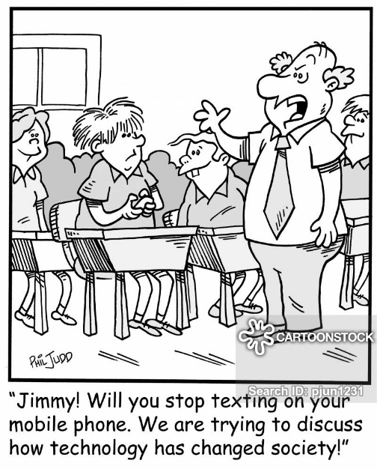
2. Are mobile phones a negative side (=côté) of technology? Why? Why not? 80 words minimum.

